**Monay Wallet**

**Introduction**

**Purpose**

This document aims to present software specifications and architecture of the Monay wallet that will help the development team properly understand the system. It will explain the scope and features of the system, the function of the system, the constraints under which it must operate, and how the system will react to external stimuli. This document is intended for the system's stakeholders and developers.

**Scope**

Monay wallet is a Digital Wallet for fast electronic payments. Customers can easily log in to the application, enable card, bank, and local payment methods and pay when customer shopping using their devices so that they don't need to carry their cards around. It provides a wide range of features such as easy login, an overview of recent transactions, a QR code to scan money, auto top-up, secondary accounts, and link bank accounts.

**Overview**

**Stakeholders**

**Primary stakeholders**

1. **Primary Users: Individual users. The primary user can go through the full KYC or KYC lite which determines their spending limits. The primary wallet holder will set a limit to the secondary wallet and the secondary wallet can only perform transactions within the limit set to his wallet. Primary wallet holders can also self-fund or receive or send funds for free.**
2. **Secondary Users: Could be Employees, Servants, Relations, Workers, etc. Primary users or Merchant controls the secondary users. One primary user can have multiple secondary users. All the transactions made by the secondary wallet holder are known to the primary wallet holder. A secondary user can go through the full KYC or KYC lite which determines their spending limits.**
3. **Merchant: This could be a Business, Corporation, Retailer, Shopkeeper, Online Store, or basically any Merchant with full KYC.**
4. **Payment Processors:** Along with the acquiring bank, a relationship with a processor is necessary to operate as a payment facilitator. Fiserv and WorldPay is the payment processor for Monay GPS in the US. The processor is responsible for processing and settling the transactions that are initiated by the payment facilitator’s sub-merchants. When a consumer uses their card to make a purchase, the processor is the entity that receives the initial authorization request and sends that request to the applicable card network, which sends back the authorization response. Once the transaction is completed, the transactions are settled daily, and then the cardholder’s bank sends the funds to the acquiring bank.

**Secondary stakeholders**

* **Acquiring Banks:** Monay GPS as a payment facilitator must agree with an acquiring bank or payments institution, which must be licensed by the card networks. For purposes of simplicity, this entity will be referred to as the acquiring bank. Since the acquiring bank assumes the risk of the payment facilitator, the acquiring bank first underwrites the payment facilitator ensuring they have the necessary infrastructure, technology, policies, and procedures to operate effectively.

The acquiring bank is responsible for monitoring the payment facilitator, ensuring they are keeping up with compliance and underwriting and onboarding sub-merchants responsibly. Aside from monitoring the compliance of the payment facilitator, the acquirer is also responsible for receiving the data and money from the card networks, then passing that data and money to the payment facilitator.

**Product Perspective**

Monay wallet is an e-wallet that allows one party to make electronic transactions with another party bartering digital currency units for goods and services. Money can be deposited in the digital wallet prior to any transactions or, the user's bank account can be linked to the digital wallet. Monay-GPS mobile application will be launched in US and India. Transactions are aligned to an acquirer bank through payment gateways integrated The figure shows the flow of the payment process for Monay wallet US.

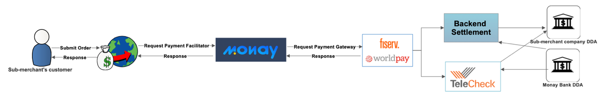

Figure 1 Payment process for Monay wallet US.

**Product Function**

* **Signup**

Users can sign up for Monay wallet as following roles:

1. **Primary Users: Individual users. The primary user can go through the full KYC or KYC lite which determines their spending limits. The primary wallet holder will set a limit to the secondary wallet and the secondary wallet can only perform transactions within the limit set to his wallet. Primary wallet holders can also self-fund or receive or send funds for free.**

* The primary wallet holder can transfer the amount to the secondary wallet holder and the secondary wallet holder can make purchases using the amount in the wallet.
* The primary wallet holder will take responsibility to recharge the secondary wallet holder when possible.
* The primary wallet holder will have a history of transactions performed by the associated secondary wallet holder.
* Primary wallet holders can choose an option to let secondary wallet holders perform transactions from the primary wallet by an amount of the limit set by the primary wallet holder. This could be useful in cases where there is a business that involves agents on site going to the end customers to perform a task and if necessary, pay the end customer.
* Primary or secondary wallet holders can help others to accept cash and transfer money for free.
* Primary or Secondary users can register to get their bills from the Merchants
* Primary wallet holders or Secondary wallet holders can select one or more payment requests and pay them all at once (single payment) using the money in their wallet or via a payment method of their choice such as UPI in India

1. **Secondary Users: Could be Employees, Servants, Relations, Workers, etc. Primary users or Merchant controls the secondary users. One primary user can have multiple secondary users. All the transactions made by the secondary wallet holder are known to the primary wallet holder. A secondary user can go through the full KYC or KYC lite which determines their spending limits.** **Once a user chooses “user” the application should allow him/her to choose a secondary user for an existing account or he/she can continue as a primary user. This process exists as of now in the current Monay wallet.** **All the transactions made by the secondary user will be visible from the primary user’s wallet.**
2. **Merchant: This could be a Business, Corporation, Retailer, Shopkeeper, Online Store, or basically any Merchant with full KYC.**

* Merchants can send payment requests to Primary or Secondary user wallet holders in with bill information as well as in the form of a bill with a link to the PDF version of the bill.

Once the user selects the role,a mobile number is required to verify the account. Monay wallet has been launched in US and India so the phone country code can be selected accordingly. A six-digit One-time password (OTP) will be sent on the provided mobile number.

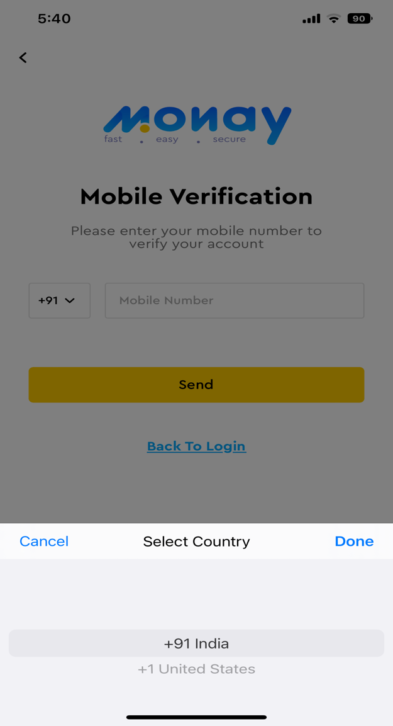

* **Sign in**

A user can sign in with a mobile number or email address.

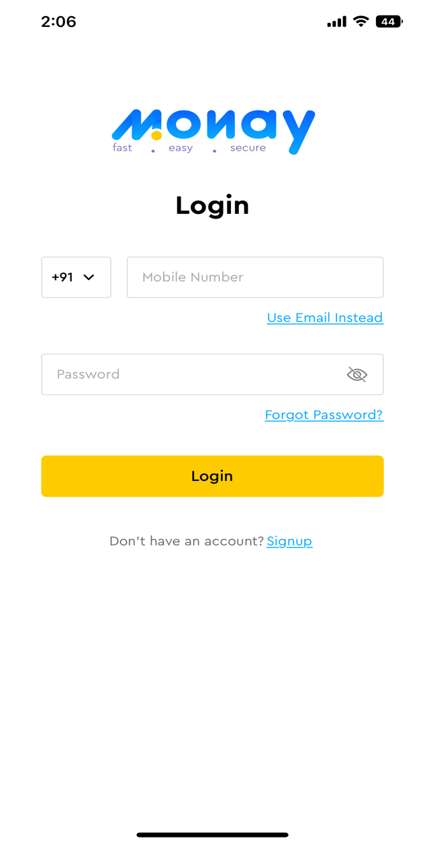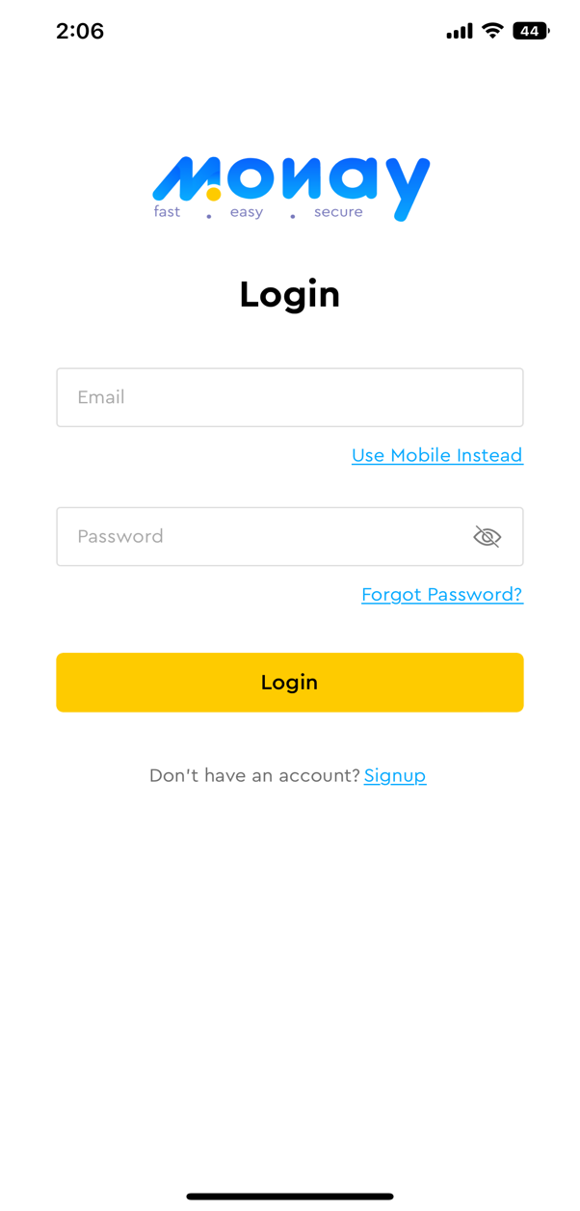

* **Dashboard**

A user can navigate to Add money, Send Money and Request Money screens. Moreover, can view useful insights such as

* + available balance
  + detail of recent payment requests
  + detail of transactions

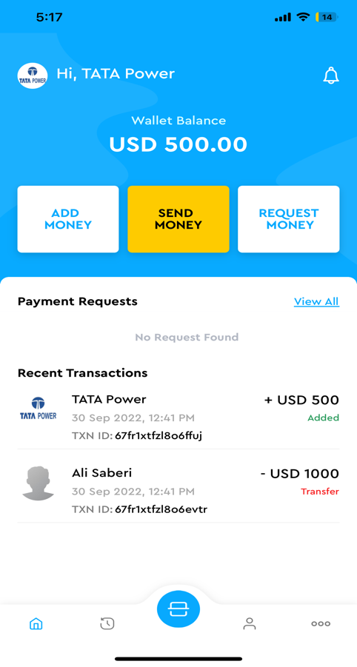

* **Add Money**

A user can add money to the wallet from bank debit and credit cards. Card details can be securely stored for future use.

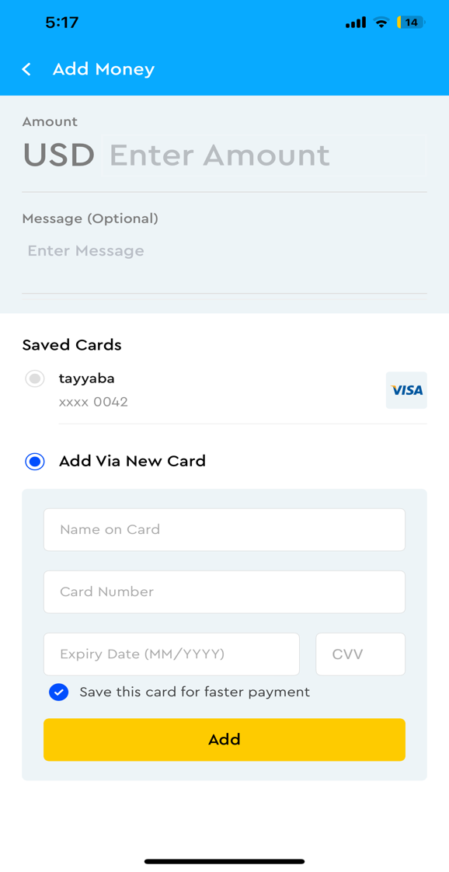

* **Send Money**

A user can send money to other users of the Monay wallet. Users can be searched from the contacts stored or QR code.

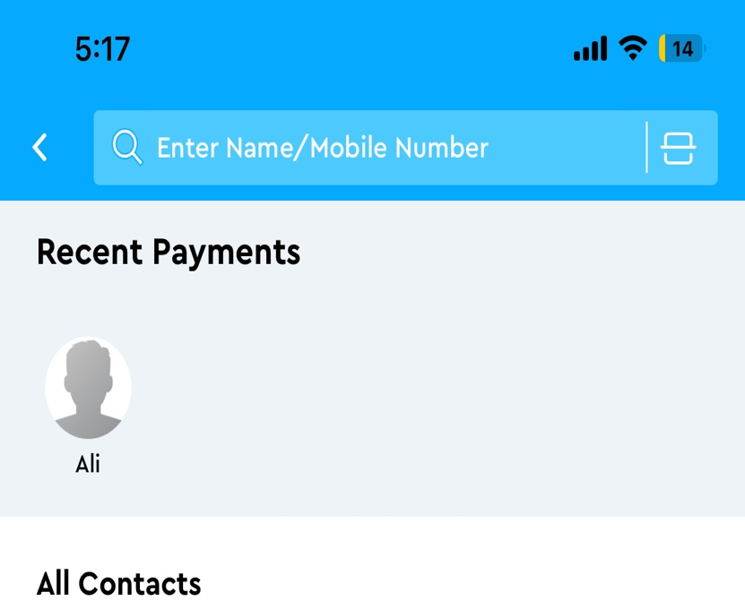

* **Request Money**

A user can request money from other users of the Monay wallet. Users can be searched from the contacts stored or QR code.



* **Notifications**

The user will receive notification of send money and received money.

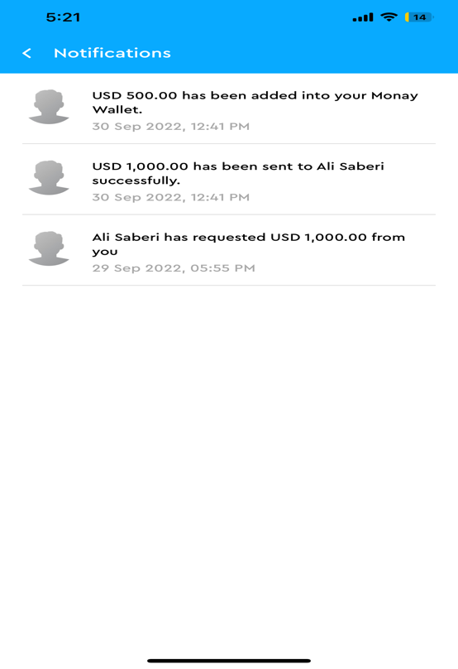

* **My Transactions**

A list of sent and received transactions will be displayed list-wise. Transactions can be filtered by date, name, transaction type, minimum price, and maximum price. Following transactions are possible using the Monay wallet.

1. Wallet-to-wallet transfers.
2. Withdraw the amount from the wallet to a bank account or UPI ID or other possible methods.
3. Recharge the wallet using any of the payment modes like UPI, Credit / Debit Card, Bank Account, internet banking, etc.
4. Pay-outs:
   1. Wallet to any bank account (basically, customer can make purchases at any store / outlet / ecommerce website etc)
   2. Wallet to any UPI ID
   3. Scan QR (dynamic / static) to pay from wallet.
5. Payment against a Biller’s Payment Request
   1. Direct UPI to a UPI ID against a Payment Request
   2. From Wallet
   3. Against a Debit Card
   4. ISO 2022 Payment using RTP

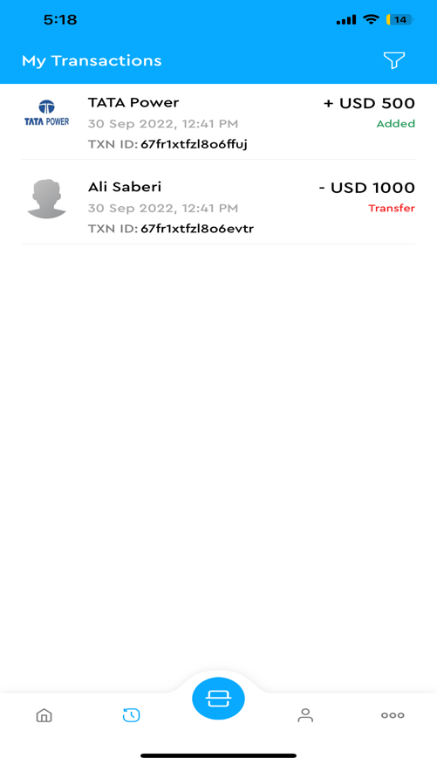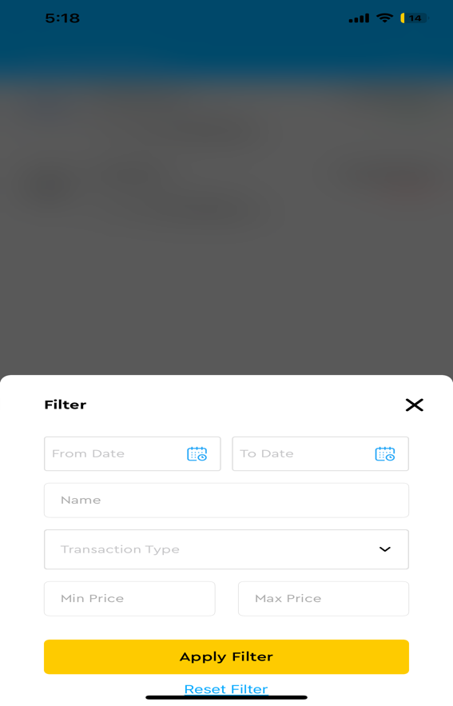

* **QR Pay**

Contactless payment by QR code feature is available in Monay wallet. Users can receive and receive money with a QR code generated by the application. This avoids many of the traditionally associated with electronic payments such as payment cards, payment networks, payment terminals, and merchant accounts.

* + **Pay Money**

Monay wallet allows scanning a QR code from the mobile app. To make a QR code payment, the consumer scans the QR code sent by the other user with their smartphone to pay for their goods They enter the amount they have to pay and finally submit.

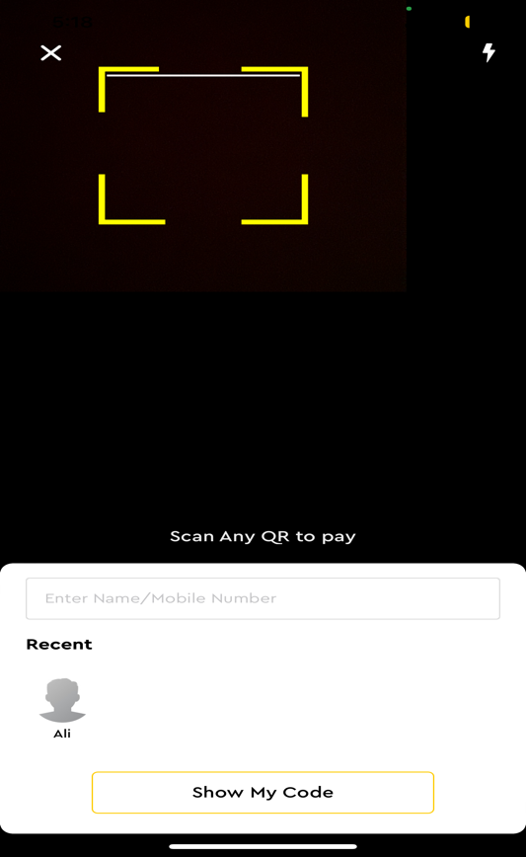

* + **Accept Money**

To accept money QR code can be shared with the users.

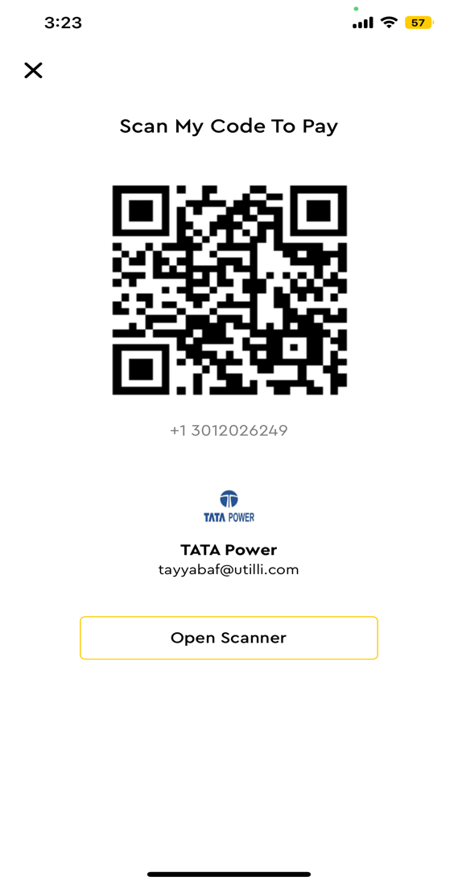

* **More**

Features and settings can are displayed in More section

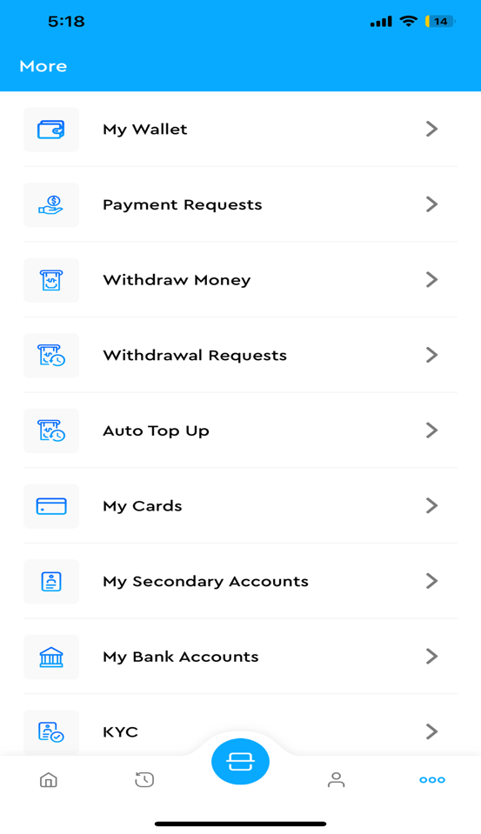

* + **My wallet**

An overview of all the transactions of the account is displayed in the My wallet section. The available balance, the total of sent money, the total of received money, and the history of all the transactions can be seen in My wallet.

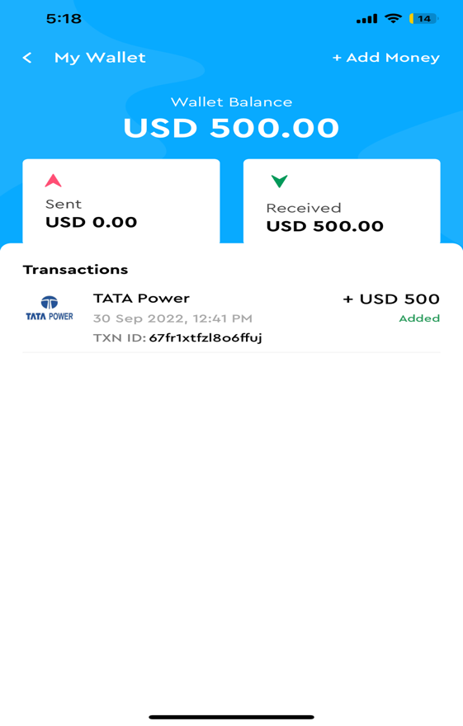

* + **Payment Requests**

A user can request another user of Monay wallet to share money. A payment request has the following three statuses:

* + - My request: Pending payment request
    - Received: All the received payment requests are on the account.
    - Paid: Successfully paid payment request
    - Declined: Payment requests that are not paid.

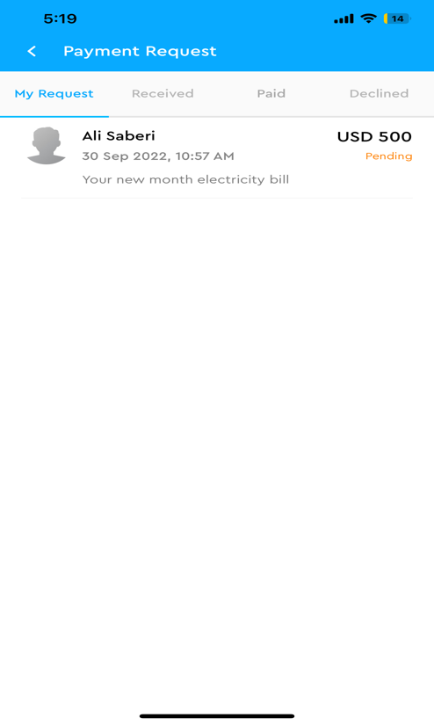

* + **Withdraw Money**

A user can withdraw the available balance from Monay wallet to a bank account. Amount to withdraw and bank details are required to withdraw money.

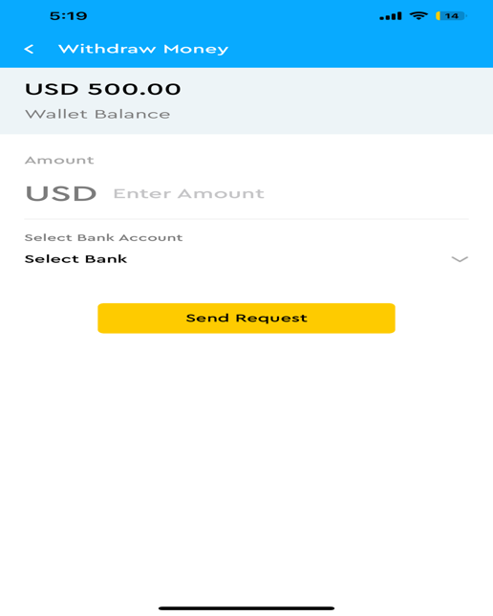

* + **Withdrawal Requests**



* + **Auto Top up**

Wallet balance can be automatically recharged of a certain amount when it reached a specified minimum amount. The user will specify the minimum amount on which auto pop-up will occur, the amount to be recharged, and card details from which the amount will be transferred to Monay wallet. Only cards that do not require CVV on every transaction can be used. The auto top-up feature can be enabled or disabled at any time.

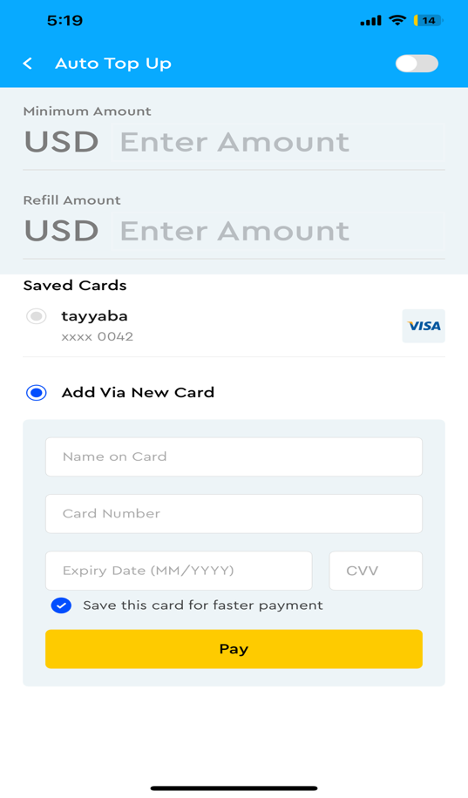

* + **My Cards**

Monay wallet can be linked to the card to recharge your balance or withdraw money to the bank account. All the cards for the purpose will be securely tokenized.

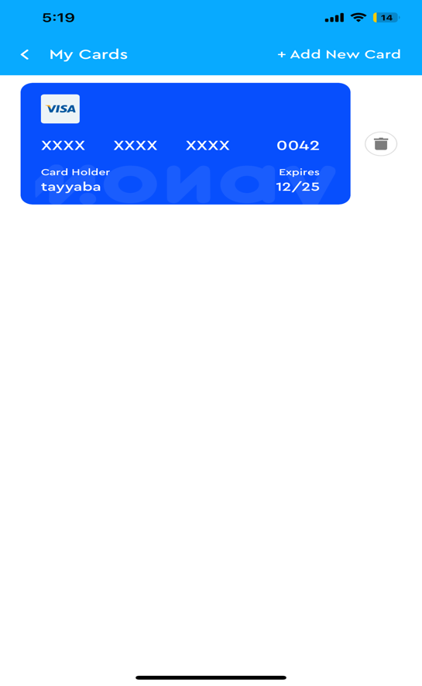

* + **My Secondary Accounts**
  + **My Bank Accounts**

Monay wallet can be linked to the bank account to recharge the balance or withdraw money to the bank account. All the bank details for the purpose will be securely stored.

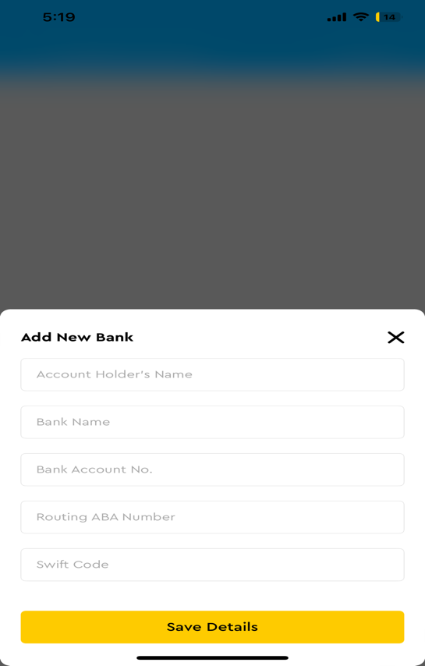

* + **KYC**

Know your customer is the process to verify the user details. KYC details will update according to the country selected.

* + - **Full KYC**

All the details are required for the merchant account.

* + - **KYC Lite**

Minimum fields are required for primary accounts.

* + **Share and Invite**

To add a secondary account user can scan the QR code or click on the invite link.

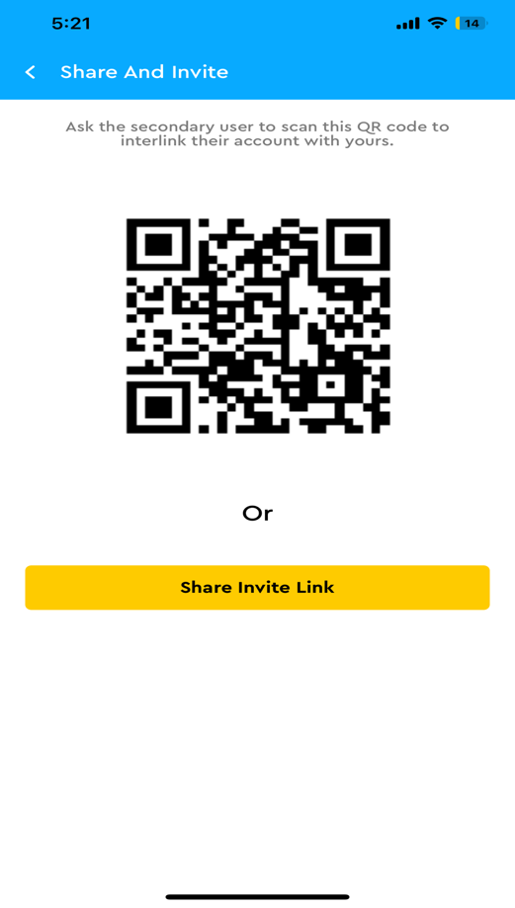

* + **Settings and support**

Users can configure and customize the settings, configure payment methods.,and manage notifications using the Settings and support tab.

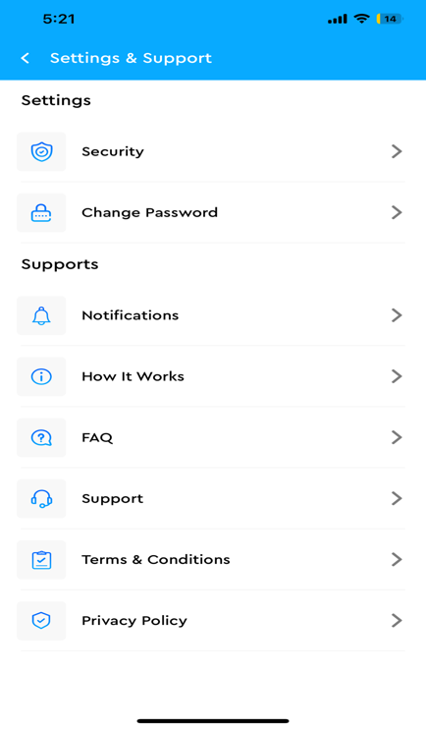

* + **Security**

For secure login and transaction, a 4-digit PIN is set up that will be required on every transaction. Moreover, to make application login secure Face ID, Fingerprint and PIN can be set up.

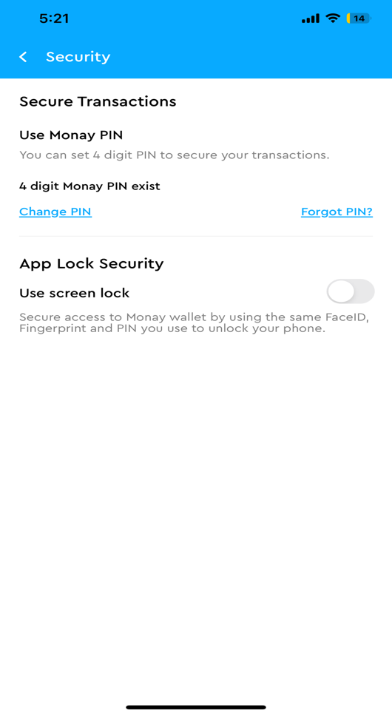

* + **Change Password**

Password can be reset from the change password tab.

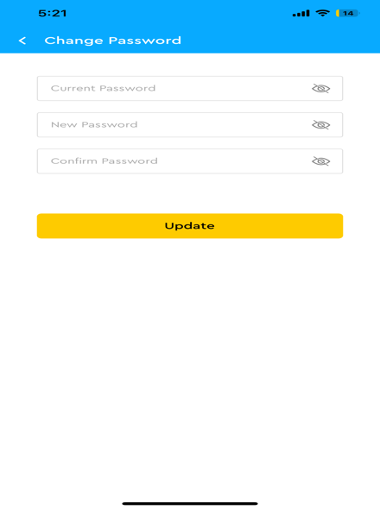

**Administration portal**

There will be an administration portal for the Monay wallet where Tilli Admin can manage all the users, transactions, and KYC details. There will be a Super admin and multiple sub-admins.

**Super Admin**

A super admin will have the privilege to perform the following functions:

* **Dashboard**

Admin Dashboard will display useful insights such as follows:

* + Total Users
  + Total Merchants
  + Total Withdrawal Request
  + Pending Withdrawal Request
  + Payment Request
  + Total Transactions
  + Successful Transactions
  + Failed Transactions
  + Sent Money
  + Received Money
  + Withdraw Money
  + Payment Statistics
  + Transactions Statistics
  + Recent Users
  + Recent Merchants

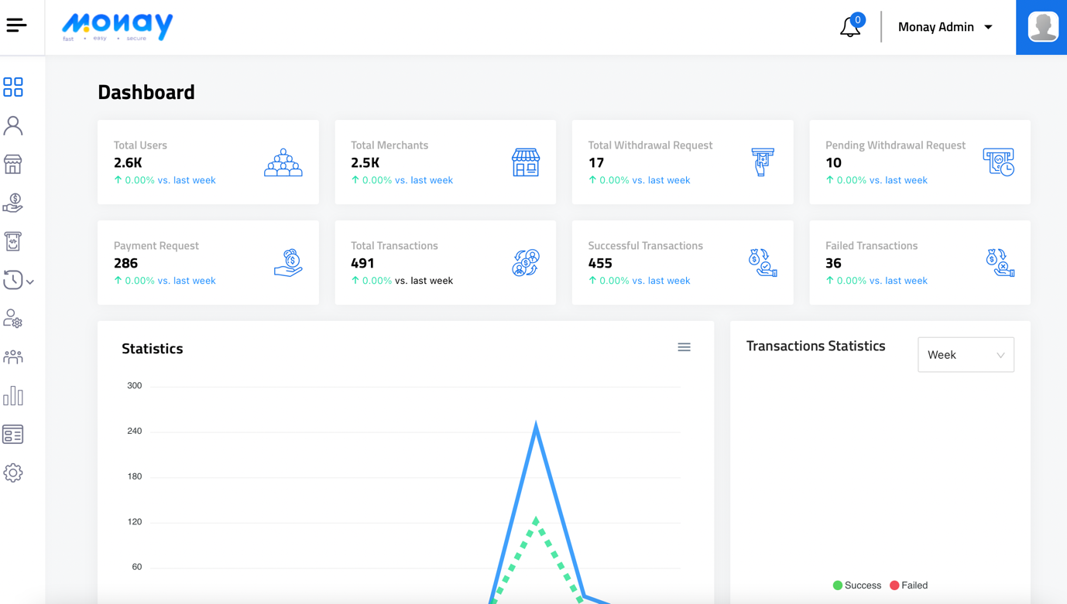

* **Users** 
  + The following information will be displayed for Monay wallet users
    - Name
    - Role
    - Mobile Number
    - Customer ID
    - Verification
    - Registered At
    - Status
  + User’s information can be exported to excel
  + The information can be filtered from the following fields
    - Name
    - Email
    - Mobile Number
    - Customer ID
    - Status
    - KYC Status
    - Registered date range

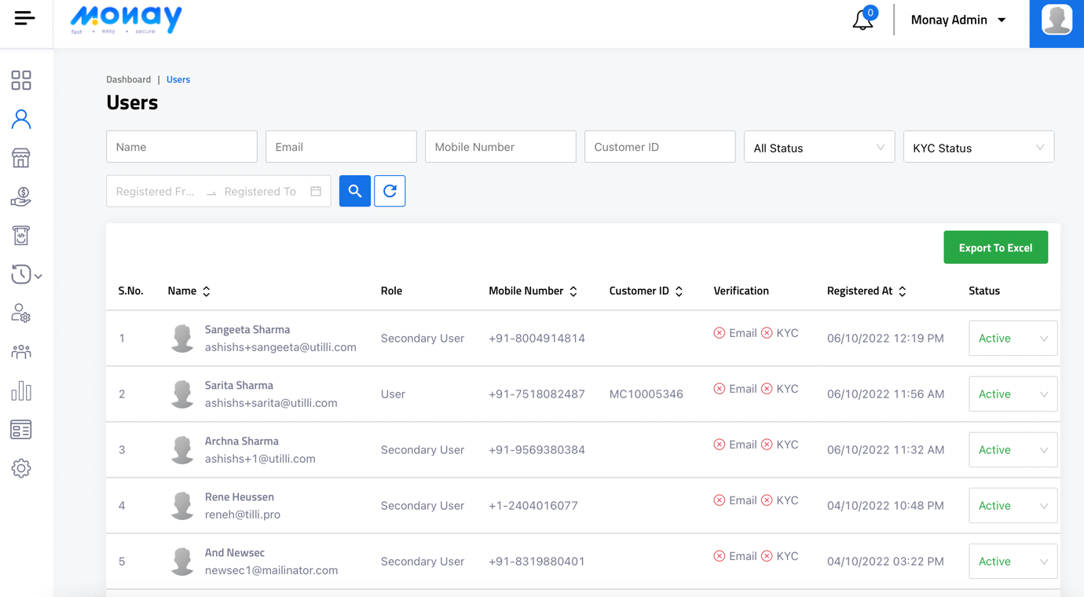

* **Merchants**
  + The following information will be displayed for Monay wallet Merchants
    - Name
    - Role
    - Mobile Number
    - Customer ID
    - Verification
    - Registered At
    - Status
  + Merchant's information can be exported to excel
  + The information can be filtered from the following fields
    - Name
    - Email
    - Mobile Number
    - Customer ID
    - Status
    - KYC Status
    - Registered date range

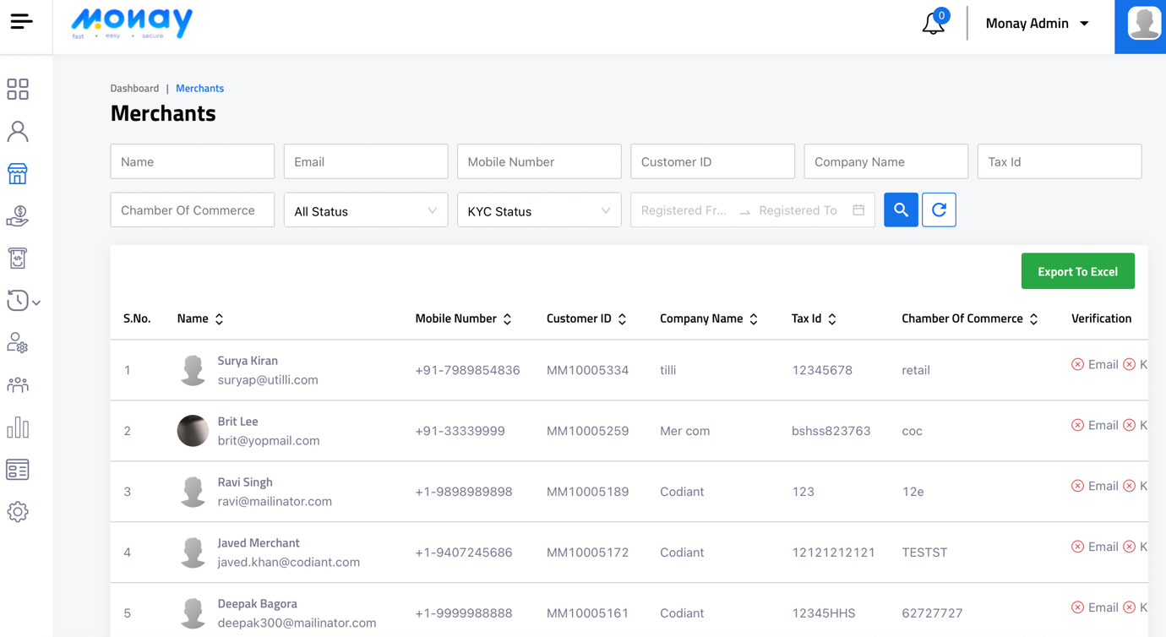

* **Payment Request**
  + The following information will be displayed for payment requests
    - From Name/Email
    - To Name/Email
    - Amount
    - Status
    - Message
    - Request On
    - Paid/Declined On
  + Payment requests information can be exported to excel
  + The information can be filtered from the following fields
    - From Name/Email
    - To Name/Email
    - Min Amount
    - Max Amount

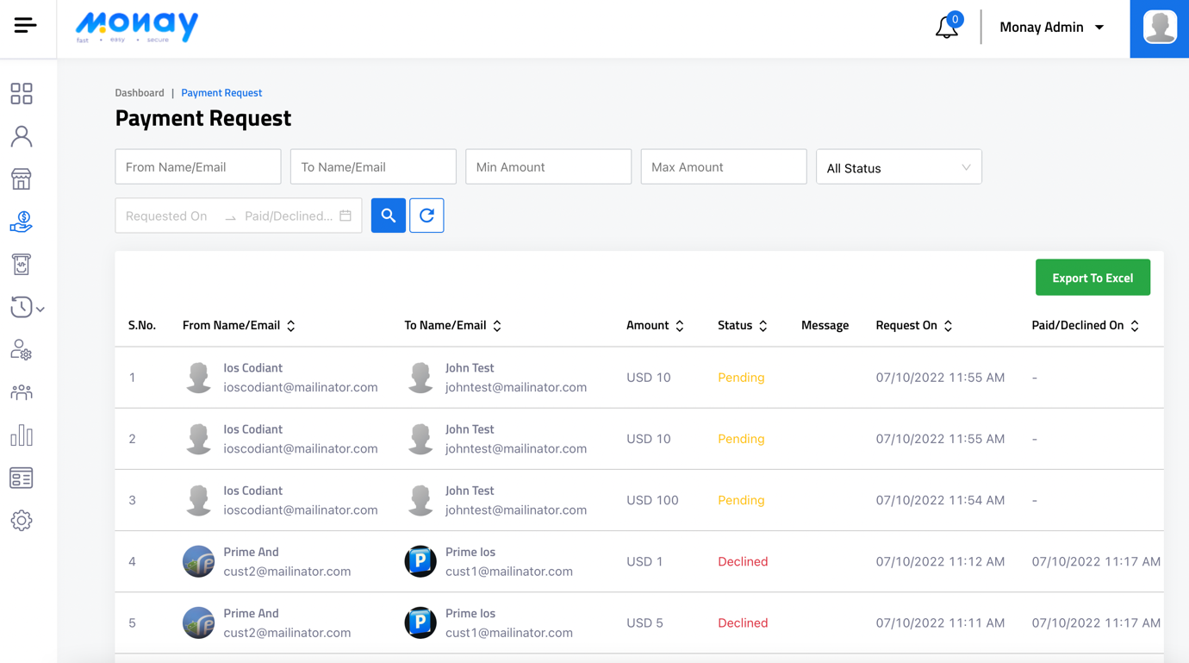

* **Withdrawal Request**
  + The following information will be displayed for Withdrawal Request
    - Transaction ID
    - Name
    - Amount
    - Transaction Status
    - Bank Account Number
    - Request On
    - Approved/Rejected On
    - Withdrawal Status
  + The withdrawal Request information can be exported to excel
  + The information can be filtered from the following fields
    - Transaction ID
    - Name
    - Email
    - Min Amount
    - Max Amount
    - Transaction Status
    - Withdrawal Status
    - Request to approved date range

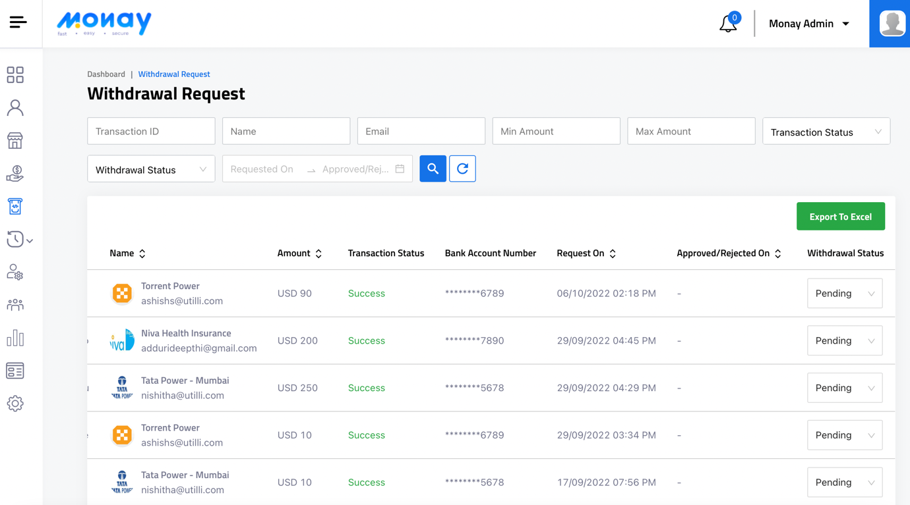

* **Transactions**
  + The following information will be displayed for Successful and Failed Transactions
    - Transaction ID
    - From Name/Email
    - To Name/Email
    - Amount
    - Transaction Type
    - Action Type
    - Message
    - Transaction Date
  + The Transactions information can be exported to excel
  + The information can be filtered from the following fields
    - Transaction ID
    - From Name/Email
    - To Name/Email
    - Min Amount
    - Max Amount
    - Transaction Type
    - Action Type
    - Transaction Date Range
* **Manage Sub Admin**
  + The following information will be displayed for sub-admins
    - Name
    - Mobile Number
    - User Role
    - Status
    - Created On
    - Action
  + The Sub-admins information can be exported to excel
  + The information can be filtered from the following fields
    - Name
    - Mobile Number
    - Email
    - User Role
    - Status
    - Created On date range
* **Manage Roles**
  + The following information will be displayed for roles
    - Role
    - Created on
    - Action
  + New roles can be added with each application module

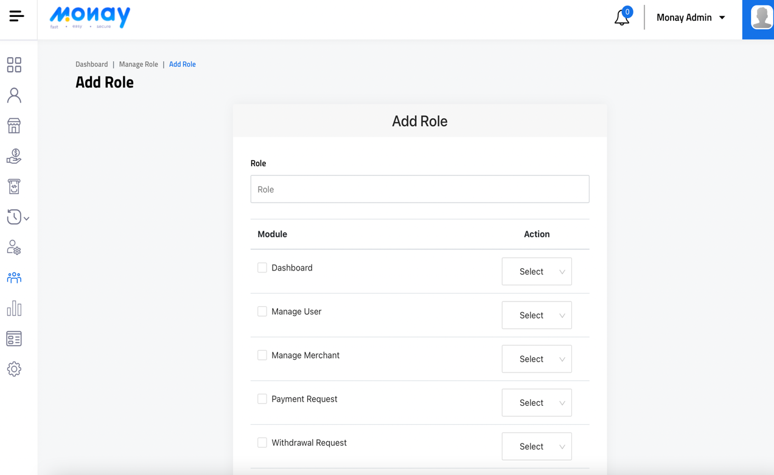

* + The information can be filtered from the following fields
    - Role
    - Created date range

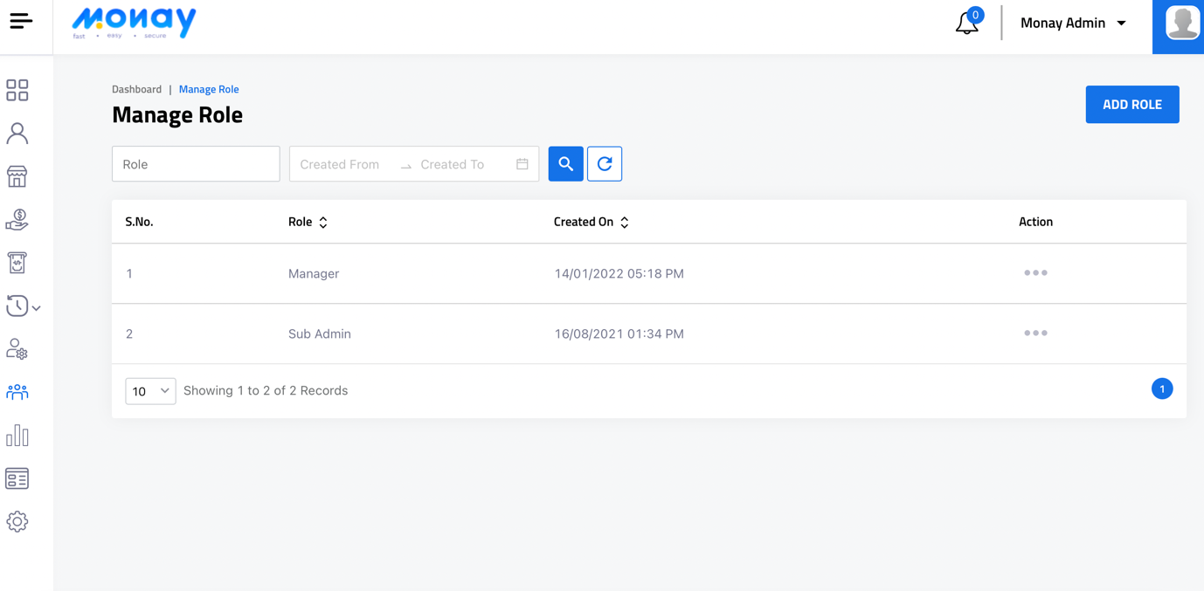

* **Activity Log**
  + The following information will be displayed for the activity log
    - Name
    - Mobile Number
    - User Type
    - IP Address
    - Start to end Date
  + The activity log information can be exported to excel
  + The information can be filtered from the following fields
    - Name
    - Mobile Number
    - User Type
    - IP Address
    - Date & Time
    - Activity
* **Manage CMS**

Page titles can be edited

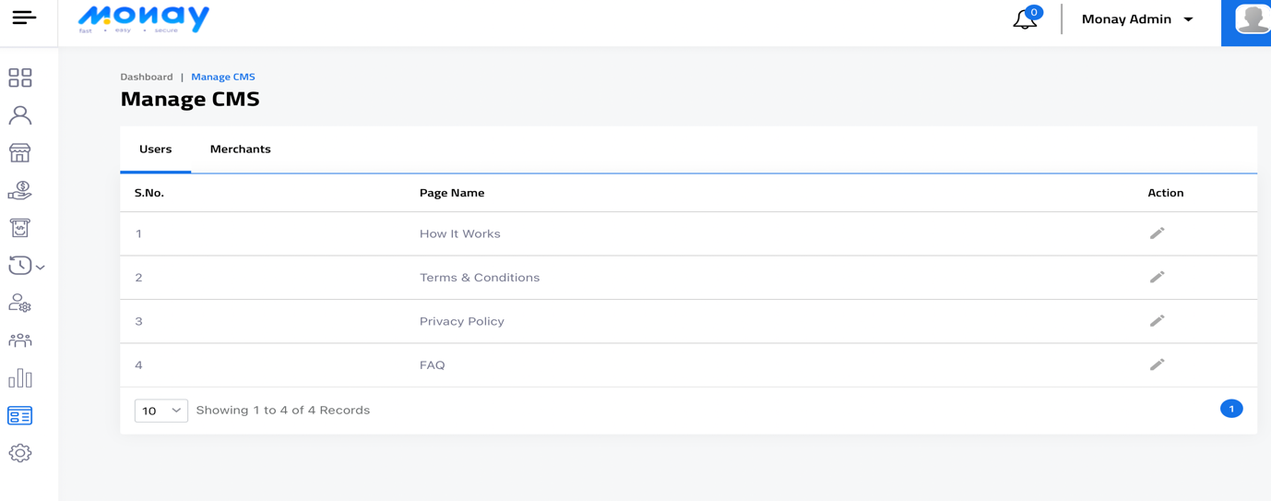

* **Settings**

Admin settings can be configured from Settings tab

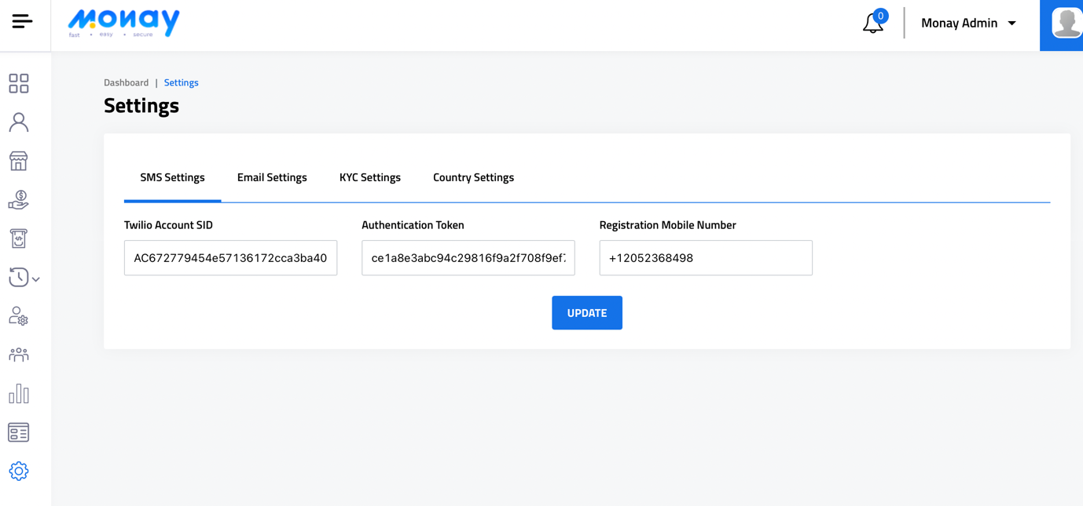

**Sub-admin**

Sub-admin can configure the application according to roles assigned by super admin

**Payment and Fee distribution**

|  |  |
| --- | --- |
| Utilli Fee Description | Pricing (USD) |
| Per Card Payment | 2.85%+25 cents (a minimum of $1.95),includes the processing fees charged by Visa,Mastercard or Discover |
| Per Token Registration/Extraction | $0.05 |
| Per Payment Confirmation Message | $0.06 |
| Per Item Processing Max (ICA & Remote Pay) | $2500.00 |
| Per Item Processing Max (CBP) | $5000.00 |

**Integration with Other Applications**

**Nudge**

**Operating System**

Monay wallet mobile application will work in the following versions of OS.

|  |  |  |
| --- | --- | --- |
| **Sr. No.** | **Operating system** | **Supported version** |
| 1. | iOS | 7/8/9/10/11/12/13/14/15/16 |
| 2. | Android | 6/7/8/9/10 |